MY SQL

## Provide a list of products with base price greater than 500 and that are featured in promo type of 'BOGOF' (Buy one get one free).

SELECT * FROM dim_products;

SELECT * FROM fact_events;

SELECT

p.product_code,

product_name,

base_price

FROM dim_products AS p

JOIN fact_events AS e USING(product_code)

WHERE promo_type = "BOGOF" AND base_price > 500

GROUP BY p.product_code,product_name

order by base_price desc;

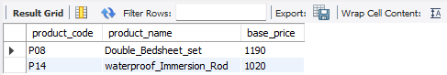

## Generate a report that provides an overview of the number of stores in each city. The results should be sorted in descending order of store count, allowing us to identify the cities with the highest store presence.

SELECT * FROM dim_stores;

SELECT

city,

count(*) AS store_count

FROM dim_stores

GROUP BY city

ORDER BY store_count DESC;

## Generate a report that displays each campaign along with the total revenue generated before or after campaign?

SELECT * FROM dim_campaigns;

SELECT * FROM fact_events;

SELECT

campaign_name,

CONCAT(ROUND(SUM(base_price*`quantity_sold(before_promo)`)/1000000,2),' ',"M") AS "Total_Revenue(before_promo)",

CONCAT(ROUND(SUM(base_price*`quantity_sold(after_promo)`)/1000000,2),' ',"M") AS "Total_Revenue(after_promo)"

FROM dim_campaigns AS c

JOIN fact_events AS e USING(campaign_id)

GROUP BY campaign_name;

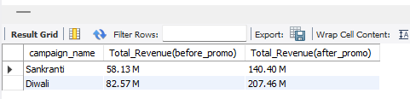

## Produce a report that calculates the incremental sold Quanitity(ISU%) for each category for Diwali Campaign. Additionally, provide randkings for the category based on ISU%.

SELECT * FROM dim_campaigns;

SELECT * FROM dim_products;

SELECT * FROM fact_events;

WITH

Diwali_Campaign AS

(SELECT

category,

SUM(`quantity_sold(after_promo)`) AS "Diwali_Sold_After_Promo",

SUM(`quantity_sold(before_promo)`) AS "Diwali_Sold_Before_Promo"

FROM dim_campaigns AS c

JOIN fact_events AS e USING(campaign_id)

JOIN dim_products AS p USING(product_code)

WHERE campaign_name = "Diwali"

GROUP BY category

ORDER BY Diwali_Sold_After_Promo DESC),

Total_No_Campaign AS

(SELECT

category,

SUM(`quantity_sold(after_promo)`) AS "Total_No_Campaign_After_Promo",

SUM(`quantity_sold(before_promo)`) AS "Total_No_Campaign_Before_Promo"

FROM dim_campaigns AS c

JOIN fact_events AS e USING(campaign_id)

JOIN dim_products AS p USING(product_code)

GROUP BY category

ORDER BY Total_No_Campaign_After_Promo DESC)

SELECT

d.category,

Diwali_Sold_After_Promo,

Diwali_Sold_Before_Promo,

ROUND((Diwali_Sold_After_Promo-Diwali_Sold_Before_Promo)/Diwali_Sold_Before_Promo*100,2) AS "ISU%",

RANK() OVER(ORDER BY ROUND((Diwali_Sold_After_Promo-Diwali_Sold_Before_Promo)/Diwali_Sold_Before_Promo*100,2) DESC) AS ISU_Rank

FROM Diwali_Campaign AS d

JOIN Total_No_Campaign AS t USING(category);

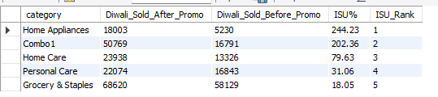

## Create a report featuring top 5 products, ranked by incremental Reavenue percentage (IR%) across all the campaings.

SELECT * FROM dim_products;

SELECT * FROM fact_events;

SELECT

dp.product_name,

dp.category,

ROUND(SUM(base_price*`quantity_sold(after_promo)`)/(select SUM(base_price*`quantity_sold(after_promo)`) FROM fact_events)*100,2) AS "IR%"

FROM dim_products AS dp

JOIN fact_events AS fe USING(product_code)

GROUP BY product_name,category

ORDER BY `IR%` DESC

LIMIT 5;

